GULISTAN & TURGUT OZAL EDUCATIONAL INSTITUTIONS
INFORMATICS LESSON PLAN

DATE :
DURATION : | 40 minutes
GRADE LEVEL: | 10th Class
SUBJECT : | Using Built-in Functions 3
OBJECTIVES : | To learn how to use predefined Excel functions

LESSON PLAN
Key words:
Materials used: | Microsoft Excel 2003 Book, Computer
Warm-up questions:

Introduction and explanation of the lesson;
3 MAX FUNCTION
Returns the largest value within the range of cells.

4 MIN FUNCTION
Returns the smallest value within the range of cells.

Example 5.6:
According to the following Figure 5.11, write the necessary formulas into cells D9 and D10 to find
the highest and the lowest averages.

Solution:
Write “=max(H3:H9)” into cell D9 and “=min(H3: H9)” into cell D10 to find the maximum and
minimum averages.

5 COUNT FUNCTION
Counts the number of cells that contain numeric values. You can use this function to avoid #DIV/0! errors. (division by zero)
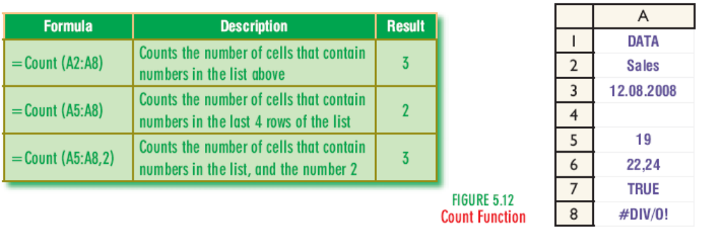
CONCLUSION:

HOMEWORK:

Teacher Director

